- Access my maths at www.mymaths.co.uk Username: bradford Password: hexagon
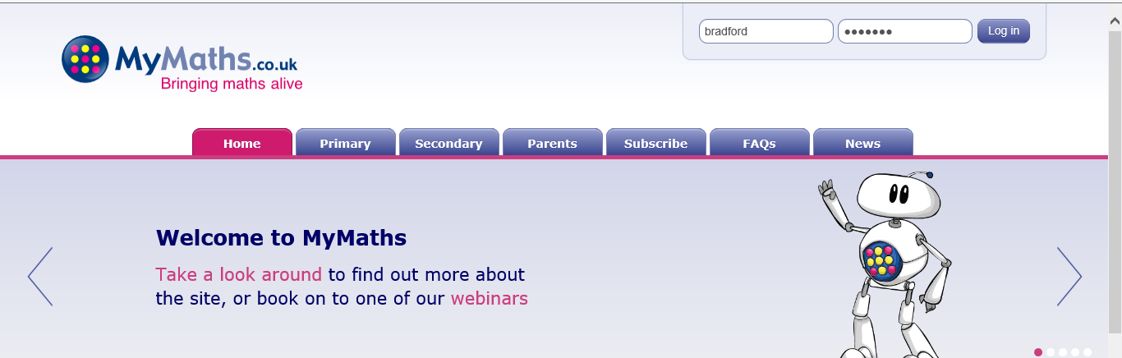
- On the next page, if you have been given an individual login, you can login through My Portal
Username: 4 digit number Password: 3 lowercase letters

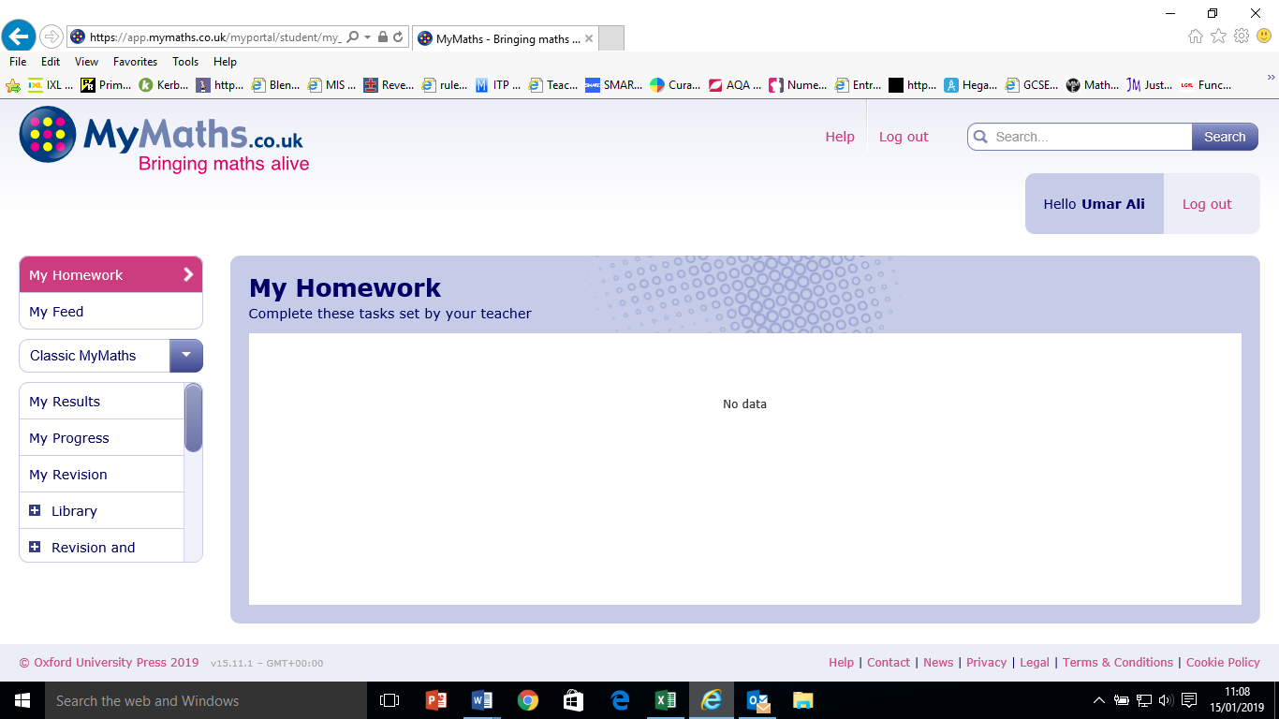
- If you have been set tasks by your tutor, you can access them here. Otherwise, click the back button to access resources

- Choose from the maths areas on the left (e.g. number, shape, date) and topic (e.g. decimals or fractions). Watch the lesson and complete online homework
